Figure 1:

* In the brain, the perforant pathway is a neuronal route from the entorhinal cortex (EC) to all the fields of the hippocampal formation, including the dentate gyrus (DG), CA fields (cornu ammonis), and the subiculum. To detect visually activation of the neurons within this pathway the researchers use c-Fos labeling (red dot points in the various images of figure 1). The proto-oncogene c-Fos can be readily detected with immunofluorescence to map groups of neurons that display changes in their activity, and is used in the paper to show levels of neuronal activation in various regions of the hippocampus [1] [2].
* 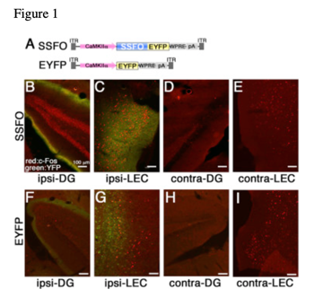In the *in-vivo* experiment illustrated by figure 1 and pictures B-I, the researchers want to show that unilateral optogenetically stimulated LEC neurons exhibit levels of neuronal activation (green color), on the same side of the entorhinal cortex (ipsi-LEC or ipsi-DG). Levels of neuronal activation of LEC neurons in the ipsilateral LEC and DG are higher compared to the levels of neuronal activation of the contra-side (contra-LEC and contra-DG). In addition, the images show that SSFO-infected mice compared to the EYFP-injected mice for the same regions of the hippocampus, have higher level of neuronal activation: activation in green (EYFP), images B and C vs. F and G, and the neuronal activation is particularly visible on image C. The researchers also point that non-stimulated neuron in LEC (ipsi or contra-LEC pictures E, G or I) still show some levels of activation detected by c-Fos labeling.

To perform this experiment, the researchers inject mice with either an ontogenetically induced activator SSFO and a genetic encoded protein EYFP or only the GEI EYFP; both under control of a CAMKIIα promoter (Ca2+/calmodulin-dependent protein kinase II alpha) using an AAV vector described by picture A:

* One group of mice is injected with an adeno-associated virus (AAV) expressing SSFO-EYFP. Stable step-function opsin (SSFO) is a mutated version of channelrhodopsin (hChR2(C128SS)) that puts neurons in a state of excitability up to 30mins after activation by a pulse light. The last effect can be reversed by a brief pulse of a deactivation light (Figure A) [3].
* The other group is injected with an AAV vector with a similar design to the one used for the first group; the difference being that it does not contain the optogenetic activator SSO (Figure A).

Figure 2

* The entorhinal cortex is traditionally the first area affected in AD, and more specifically the lateral entorhinal cortex (LEC). Amyloid β (Aβ) plaques are hallmarks of Alzheimer’s disease (AD). Aβ40 and Aβ42 are the two main types of Aβ polymers which have direct role in plaque formation. Compared to Aβ40, Aβ42 is less abundant, highly insoluble but severely neurotoxic [4]. The researchers stimulate intermittently SSFO-injected mice by light (1 x/min for 4 hr.) the neurons in the hippocampus. Using in vivo microdialysis they also measure every hour the average level of Aβ42 in the interstitial fluid (ISF). They report and plot the mean relative levels of ISF Aβ42 every hour starting, 3 hours prior to optogenetic stimulation, up to 5 hours after the stimulation. The curve shows a rapid increase of the ISF Aβ42 within an hour after the stimulation, which slowly reaches a peak, 2 hours after optical stimulation, and thereafter slowly decreases, and 5 hours after the stimulation, back but not quite, to the initial level at the time of the stimulation. Therefore, they show that the optogenetic stimulation neurons of the entorhinal cortex increases significantly the level of ISF Aβ42 (up to 23% increase) for a long period of time (5 hours) (Figure 2 – A).
* 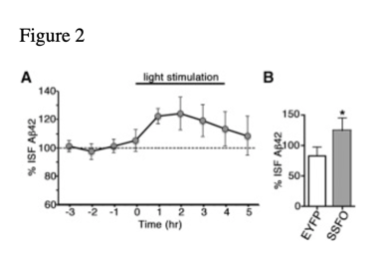Also, the authors of the paper run a statistical analysis to test the hypothesis that ISF Aβ42 level in the hippocampus of SSFO-injected mice, mice with hippocampus optogenetically stimulated, are significantly higher at 1 hour of stimulation than that for the mice non-optogenetically induced (EYFP-injected mice).
* Finally, the graph (Figure 2 – B) shows that no significant increase of % ISF Aβ42 of the AAV-EYFP light stimulated mice is observed compared to AAV-SSFO mice.

In conclusion, the authors of the paper want to show 1) application of optogenetic techniques in-vivo to stimulate specific neuronal pathway, the hippocampal perforant pathway, in APP Tg mice to study Aβpathology and 2) intermittent optical stimulation of the LEC results in a significant increase of ISF Aβ42 level.

**References**

[1] “C-Fos - an overview | ScienceDirect Topics.” https://www-sciencedirect-com.proxy1.library.jhu.edu/topics/neuroscience/c-fos (accessed Oct. 26, 2021).

[2] S. M. Appleyard, “Lighting Up Neuronal Pathways: The Development of a Novel Transgenic Rat that Identifies Fos-Activated Neurons Using a Red Fluorescent Protein,” *Endocrinology*, vol. 150, no. 12, pp. 5199–5201, Dec. 2009, doi: 10.1210/en.2009-1234.

[3] K. M. Tye and K. Deisseroth, “Optogenetic investigation of neural circuits underlying brain disease in animal models,” *Nat. Rev. Neurosci.*, vol. 13, no. 4, pp. 251–266, Mar. 2012, doi: 10.1038/nrn3171.

[4] S. Tiwari, V. Atluri, A. Kaushik, A. Yndart, and M. Nair, “Alzheimer’s disease: pathogenesis, diagnostics, and therapeutics,” *Int. J. Nanomedicine*, vol. Volume 14, pp. 5541–5554, Jul. 2019, doi: 10.2147/IJN.S200490.